Biodiversity Duty Report for South Cambridgeshire District Council

2021-2025
Contents
Biodiversity Duty Report for South Cambridgeshire District Council 1
2021-2025 2
Executive Summary 3
Background 4
About South Cambridgeshire 5
South Cambridgeshire District Council (SCDC) 6
Functions 6
Biodiversity core values 7
Influence on Biodiversity 7
Challenges and Constraints 9
Section 1. Our Biodiversity Duty Actions 10
Strategies 10
Areas Managed for Nature 13
Community Action and Engagement 15
Partnerships 19
Summary – Our Biodiversity Duty Actions 22
Section 2. Biodiversity Net Gain (BNG) 22
Policy Framework 23
Biodiversity Duty 23
Actions to meet BNG obligations 23
Biodiversity Net Gain (BNG) Data 25
Future Planning Actions for Biodiversity 28
Section 3. Monitoring and Evaluation 29
Summary – Monitoring and Evaluation 30
Section 4. Relevant Strategies 30
Summary – Review of Relevant Strategies 35
Section 5. Future Actions 35
SCDC Corporate Plan 2025 – 2030 36
Climate and Nature Strategy + Action Plan 36
Greater Cambridge Local Plan (Draft) 38
Other Future Actions 40
Future Actions Summary 40

Executive Summary
Between 2021 and 2025, South Cambridgeshire District Council (SCDC) has made progress in fulfilling its biodiversity duty, as mandated by the Environment Act 2021. This report outlines the Council’s strategic actions, achievements, and future plans to conserve and enhance biodiversity across the district.
SCDC declared ecological and climate emergencies in 2019, which led to the development of the Zero Carbon Strategy (2020) and Doubling Nature Strategy (2021). These strategies, along with their accompanying action plans, have guided the Council’s biodiversity efforts over the past five years. Key initiatives include enhancing nature on Council estates, influencing planning policies, and engaging communities through grants and outreach.
The Council has:
- Managed 21 areas for nature on its estate and identified over 20 more for future enhancement.
- Supported over 40 biodiversity projects through the Community Chest and Zero Carbon Communities Grant schemes.
- Planted 758 native trees across 100 parishes via the Six Free Trees Scheme.
- Delivered community engagement through newsletters, climate conferences, and partnerships with local organisations.
- Partnered with authorities and community groups to identify nature and green infrastructure networks as well as habitat banks
As a local planning authority, the Greater Cambridge Shared Planning service (GCSP) has implemented mandatory Biodiversity Net Gain (BNG) conditions on planning applications since February 2024. It has facilitated the creation of eight offsite habitat banks covering 200 hectares and adopted a Biodiversity Supplementary Planning Document (SPD) recommending 20% BNG for new developments.
Looking ahead to 2026–2030, SCDC will be guided by three key documents:
- Climate and Nature Strategy (2026) – aiming to double land managed for nature and achieve net zero emissions by 2050 across the district.
- Greater Cambridge Local Plan (2026) (at draft stage at the time of writing this report) – embedding biodiversity, green infrastructure, and tree canopy policies.
- Cambridgeshire & Peterborough Local Nature Recovery Strategy (LNRS) – focusing on landscape-scale nature recovery.
SCDC will continue to empower communities, collaborate with partners, and refine planning policies to meet biodiversity and climate goals. These efforts reflect the Council’s enduring commitment to “Being green to our core” and its role in shaping a resilient, nature-rich future for South Cambridgeshire.

Background
The biodiversity duty is a statutory obligation requiring local authorities and planning authorities to conserve and enhance biodiversity. It is set out in Section 40 of the Natural Environment and Rural Communities Act 2006 as amended by the Environment Act 2021. This duty involves setting appropriate policies and objectives for biodiversity and taking actions that align with those goals. Section 40A of the Act further sets out the requirement for local authorities to report on actions which fulfil the biodiversity duty, and for planning authorities to report on actions contributing to biodiversity net gain (BNG).
South Cambridgeshire District Council (SCDC) recognises the urgent need to prioritise nature and climate action. In 2019, the Council declared ecological and climate emergencies and subsequently made significant considerations for enhancing biodiversity. The first considerations for biodiversity actions were set out within the Zero Carbon Strategy (2020), followed by the Doubling Nature Strategy (2021). These were also accompanied by an Action Plan for both, which is a living document that tracks progress on actions and where newly considered actions can be added. These key documents will form the basis for this report on biodiversity duty actions.
This report will summarise actions taken by SCDC between 2021 and 2025 and set out its plan for action for the following five years (2026-2030). It will detail how other relevant local and regional nature recovery, species conservation, and protected sites strategies have informed South Cambridgeshire’s policies, objectives and actions, and help identify areas for collaboration within and beyond the district council.
In accordance with Section 40A, this report will provide
- a summary of the actions South Cambridgeshire District Council (SCDC) has taken between November 2021 to December 2025 to fulfil the biodiversity duty, covering all SCDC actions after Environment Act 2021 came into force (November 2021). In addition, it will provide monitoring and evaluation data to show our progress against the objectives.
- a summary of the authority’s plans for complying with the biodiversity duty over the period of five years following the period covered by the report (2026-2030).
As a local planning authority (GCSP), this report will also provide
- a summary of actions taken by the Greater Cambridge Shared Planning (GCSP) Built Environment team in carrying out its functions under Schedule 7A of the Town and Country Planning Act 1990 (biodiversity gain as condition of planning permission) over the reporting period,
- information about any biodiversity gains resulting or expected to result from biodiversity gain plans approved by the during that period, and
- a summary of the GCSP’s plans for carrying out those functions over the five-year period following the period covered by the report (2026-2030).

About South Cambridgeshire
South Cambridgeshire is a district in Cambridgeshire, England which covers a large rural area surrounding Cambridge City. It is a rapidly growing area with a rate of population growth higher than the regional (East of England) average (9% vs. 8.3%)(SCDC, 2024). As of 2024 there are approximately 172,500 residents within South Cambridgeshire (ONS, 2024) living throughout the district’s 104 towns and parishes.

South Cambridgeshire is projected to grow to 222,345 residents by 2041, a 37.2% increase from 2021(SCDC, 2024). The Government’s ambitious target for provision of new homes to address the housing affordability crisis is a key driver for this forecasted growth - several New Towns in the district, such as Cambourne, Northstowe, and Waterbeach along with other smaller new communities will add tens of thousands of homes in the next decade. South Cambridgeshire is also a growing hub for the science and technology sector with new business parks and campuses being developed around the district.

The rapid growth in South Cambridgeshire and surrounding areas is expected to create additional pressure on the natural environment as habitats may become degraded or fragmented due to housing, agricultural and industrial expansion. Water and energy supply may also become strained due to higher demand and over-abstraction (Environment Agency, 2023). Simultaneously, this additional population may increase the demand for green infrastructure and open spaces, opening opportunities for further nature enhancements, access to nature, and biodiversity net gains.

The chart below shows that land usage in South Cambridgeshire is dominated by agriculture, followed by forest, open land and water. Although residential usage is projected to expand substantially in the near future, land used for agriculture, totalling more than 70,000 hectares (approximately 63%), represents a significant opportunity for biodiversity and nature recovery. Similarly, residential gardens which uses 4.9% of land in the district can provide habitats for local plant and animal species.

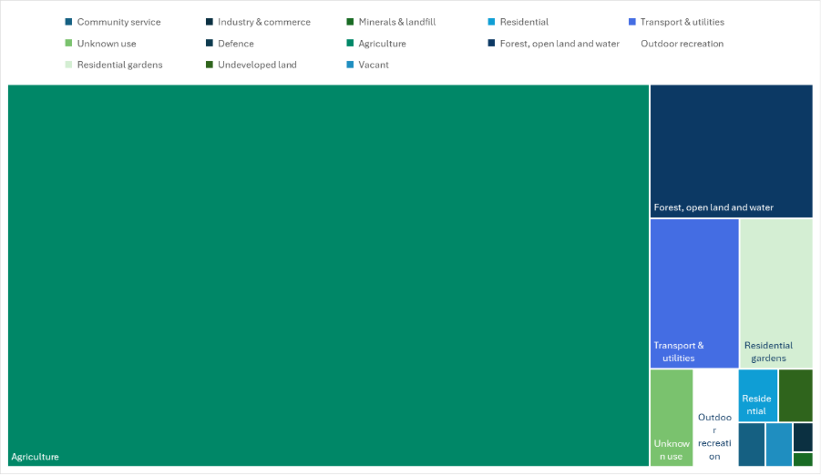
Figure 1 Proportion of total land area by usage type in South Cambridgeshire, UK Government (2022)
Changes within our district will affect neighbouring districts including Huntingdonshire, East Cambridgeshire, Fenland, North Hertfordshire, and Uttlesford with whom we share key landscapes, corridors, and ecosystems. With Local Government Reorganisation (LGR) coming into effect in April 2028, it is crucial to collaborate and plan strategically with surrounding districts, to tackle the ecological crisis on a landscape scale, and be prepared for potential impacts of development.

South Cambridgeshire District Council (SCDC)

Functions
South Cambridgeshire District Council (SCDC) is the local authority responsible for delivering a range of public services to residents and businesses in South Cambridgeshire. Its core functions include:
- Planning and development control
- Housing services (including council housing and homelessness support)
- Waste collection and recycling
- Environmental health
- Community services
- Economic development
- Council tax and business rates collection

SCDC shares two services with Cambridge City, Greater Cambridge Shared Planning (GCSP) and Greater Cambridge Shared Waste Service (GCSWS). The ICT service is shared with both Cambridge City Council and Huntingdon District Council. Functions such as transport and education are the responsibility of Cambridgeshire County Council.

SCDC is one of seven constituent councils within the Cambridgeshire and Peterborough Combined Authority (CPCA) which works with six other councils in the region (Cambridge City Council, Cambridgeshire County Council, East Cambridgeshire District Council, Fenland District Council, Huntingdonshire District Council, and Peterborough City Council). CPCA responsibilities include transport, infrastructure planning, economic growth, business support and adult education.

Biodiversity core values
In 2019, SCDC declared an ecological emergency (July) followed by the declaration of a climate emergency (November), recognising the need to take real action to address these crises. We are guided by the core value of ‘Being Green to our Core’ as set out in the previous Corporate Business Plan 2020-25, which asserts our commitment to protecting and enhancing nature in everything we do, from our own estates and operations to the wider district using our influence. A new Corporate Plan 2025-2030 was adopted in February 2025, strengthening our commitment to ‘Being Green to our Core’ by reducing carbon emissions within our own operations, enabling the rest of the district to reduce emissions, increasing tree canopy and ‘nature rich’ areas in the district.
- 2019 – SDCD Declaration of an Ecological Emergency (July)
- 2019 – SCDC Declaration of a Climate Emergency (November)
- ‘Being Green to our Core’ Corporate Value in SCDC Corporate plans 2020-2025, and 2025-2030

Influence on Biodiversity

SCDC Spheres of Influence begin from our own estates and expands outward through policies and into communities; we
- Aspire to be an exemplar on our own estate
- Use our direct influence through policies, and
- Make the most of our wider influence through partnerships and in our communities.

Biodiversity is intimately linked with land and land management; although SCDC directly controls only a small proportion of land in the district, we can influence policies and actions on land we do not control. Our approach is to widen our spheres of influence to include not only our own estate but also private developments as well as businesses and communities in the district. The Zero Carbon (2020) and Doubling Nature (2021) Strategies and accompanying action plan were made specifically to address the climate and ecological crises with realistic actions. These strategies guided our climate and nature actions between 2021 and 2025 and leveraged our influence in all three spheres to maximise our impact as a district council. A new combined SCDC Climate and Nature Strategy (2026) will continue to focus on biodiversity, nature and water, while harnessing the co-benefits from climate mitigation measures. In addition to a dedicated Climate and Environment team who are responsible for supporting climate action and improvements to nature and biodiversity in the district, colleagues in other teams such as Communities, Housing, Waste, and Economic Development also operate schemes and share communications with residents and stakeholders to influence action. These colleagues help to contribute towards our goals of doubling nature and reaching net zero carbon emissions in the district by 2050.

The local planning authority, Greater Cambridge Shared Planning (GCSP), as a shared service between South Cambridgeshire District Council and Cambridge City Council also have significant influence over the built environment and biodiversity through planning policies and regulations. In February 2022, GCSP adopted the Greater Cambridge Biodiversity Supplementary Planning Document (SPD) which provides planning guidance on meeting Biodiversity Net Gain (BNG) duties introduced by Environment Act 2021. The SPD goes beyond the statutory requirements of 10% BNG and recommends a 20% BNG for all new developments as best practice. Planning applications are reviewed by in-house ecologists to ensure the protection and enhancement of nature before, during and after development. Representing two councils, GCSP are currently developing a Greater Cambridge Local Plan which will include provisions for biodiversity, green infrastructure, and open spaces, balancing nature recovery with equitable access to outdoor spaces, particularly in new developments.

These emerging documents have incorporated previous strategies and actions and made new considerations for future actions for biodiversity. Once finalised, they will guide us in thinking about the next steps for the following five years (2026 – 2030).

SCDC Strategy Timeline:
2020 - Zero Carbon Strategy
2021 – Doubling Nature Strategy
2021 – Zero Carbon and Doubling Nature Action Plan
2026 – Climate and Nature Strategy

Greater Cambridge Shared Planning (GCSP) Policy Timeline:
2018 – South Cambridgeshire Local Plan
2018 – Cambridge City Local Plan
2022 – GCSP Biodiversity SPD
2026 – Greater Cambridge Local Plan (Draft at the time of writing)

Challenges and Constraints
In South Cambridgeshire, we are facing multiple challenges for biodiversity, including rapid development and urbanisation, compounded by the effects of climate change. Intensified development can lead to loss and fragmentation of habitats, and in turn, habitat loss can accelerate climate impacts by diminishing carbon capture and weakening natural defences against environmental shocks. As such, our approach must address both climate change and biodiversity simultaneously.
The Council’s housing estate represents a very small proportion of land in the district; highways and other large infrastructure are maintained by Cambridgeshire County Council while the rest of the land in the district is privately owned and under parish control.
Other than making improvements on our own estates, we are partnering with other local authorities to create strategic plans for nature recovery through a regional Local Nature Recovery Strategy (LNRS). We provide support and funding to parishes/community groups to implement biodiversity projects via various grant schemes. Furthermore, we promote nature-friendly practices through our communication channels including social media and printed publications. Our planning service (GCSP) also plays an important role in enhancing the environment through regulatory planning controls and mandatory BNG.
It is important to recognise that stakeholders who can implement direct actions, such as parish councils and private landowners are often stretched for resources and time to research and implement desired changes. SCDC’s role lies in facilitating actions by offering personalised support, signposting, and streamlining processes to reduce barriers as much as possible. To deliver change on district-wide scale, we rely on effective relationships with other local authorities, community groups, parishes and towns.

Section 1. Our Biodiversity Duty Actions

Strategies
Our biodiversity actions were guided by the Doubling Nature Strategy (2021) and Zero Carbon Strategy (2020) between 2021-2025.
Doubling Nature Strategy (2021)
Adopted in 2021, the Council’s Doubling Nature Strategy is a plan to significantly enhance nature and biodiversity across the district by 2050. In recognition of the ecological crisis, this strategy seeks to double South Cambridgeshire’s natural capital, which is the sum of our natural assets and ecosystems including soil, trees, air, water, and other biodiversity. We aimed to achieve this by providing more wildlife-rich habitats, increasing tree canopy cover, and improving access to green space. This ambition is in line with Natural Cambridgeshire’s “Doubling Nature” ambition, which seeks to double the areas managed for nature by 2050. Similarly, the Cambridgeshire and Peterborough Local Nature Recovery Strategy (LNRS) sets out a quantified goal of doubling wildlife-rich habitats in Cambridgeshire and Peterborough from 8% to 16% by 2040. These enhancements to biodiversity will translate to ecosystem services and bring co-benefits to businesses and residents in South Cambridgeshire.
Our Doubling Nature actions are divided into the three spheres of influence
- Actions we can do on our own estate including Council housing land, commercial sites, and private land managed by the Council (Drainage and Churchyards). Examples include improved land management practices such as reduced mowing, wildflower and native species planting, and watercourse management to promote wildlife.

- Actions we can directly influence through policies (planning and development), not only by complying with BNG requirements, but also actively identifying opportunities for more green infrastructure within new developments.

- Actions we can influence through partnerships with external stakeholders including other local authorities and community organisations. We can also support and encourage more actions for biodiversity through community engagement and funding schemes, for example providing free native trees for Parishes to plant via the Six Free Trees scheme, holding nature-focused conferences and events, and funding biodiversity projects within communities. We can also inspire behaviour change through various communication channels at SCDC.

A detailed evaluation of our ‘Doubling Nature’ actions is provided in the next Section – monitoring and evaluation.
Zero Carbon Strategy (2020)
The Zero Carbon Strategy was adopted by SCDC in May 2020. It outlines the Council’s commitment to tackling climate change by reducing carbon emissions across the district. The Council aims to reduce emissions from its own operations (services and buildings) by 75% by 2030 but also sets out ambitious goals of 50% reduction in carbon emissions district-wide by 2030 (from 2018 levels) and achieving net zero carbon emissions by 2050.
This strategy works in synchrony with the Doubling Nature Strategy (2021) to enhance biodiversity. For example, increased tree cover can simultaneously capture more CO2, and create new habitats for wildlife, increasing biodiversity in the district. Along with land management, the strategy sets out other important ways we can reduce carbon emissions through policies in transportation, recycling and waste, and energy use, both internally and in the district at large.
The link between carbon and biodiversity is clear; warming climates in recent decades, along with urbanisation and development have led to a devastating loss of plant, animal, bacterial and fungal species around the globe. By reducing our carbon footprint, we can help to conserve existing species and welcome the return of declined species in a more hospitable environment.
Zero Carbon and Doubling Nature Action Plan (2021)
The Action Plan seeks to respond to the climate and ecological emergencies by enhancing nature and green infrastructure through planning mechanisms and community action. Furthermore, the plan sets out ways we can lead by example by enhancing nature on our own estates and awarded watercourses. Actions have been continually added between 2021 and 2025, and updated in the action plan log, which served as a foundation for the Climate and Nature Action Plan (2026).
The following actions within the previous (2021-2025) Action Plan directly relate to SCDC’s biodiversity duty:
On our own estate and through our operations
- Add a step to the Housing Estates Inspection process to identify and take forward opportunities for tree-planting and other wildlife-friendly initiatives in appropriate locations.
- Complete the audit of trees on Council-owned housing estates and undertake recommended maintenance work.
- Identify appropriate locations and set up three pilot schemes to establish wildflower strips or patches on Council housing estate land.
- Review management of awarded watercourses with a view to action to improve biodiversity.
- Maintain an Environmental Management System for the Greater Cambridge Shared Waste Service.
Through Planning
- Progress planning policies related to doubling nature as part of wider work on green infrastructure on the Greater Cambridge Local Plan Preferred Options consultation and work on the draft plan.
- Draft and adopt a Greater Cambridge Biodiversity Supplementary Planning Document (SPD) to update and strengthen guidance in the SCDC Biodiversity SPD (2009).
- Promote good practice via publications in securing benefits to biodiversity through development.
By working with partners
- Work with Highways England to ensure positive environmental legacy from A428 Improvement works.
By supporting community action
- Review and relaunch the Wildlife Enhancement Grant (WES) scheme (later incorporated into the Community Chest Grant).
- Provide six free trees to every parish or town.
- Explore options for delivering support for parish and town councils and community groups to create and deliver Local Nature Recovery Plans.
- Continue to support volunteers to play an active role in conserving and enhancing their local trees and woods through our role as registered Tree Warden network co-ordinator for this area with the Tree Council.
- Run a Climate and Environment fortnight of online events highlighting successful community action and inspiring and encouraging further action.
- Promote gardening for nature to our residents to increase awareness and better enable residents to preserve and enhance nature within their own spheres.
- Deliver communications campaigns around climate change and the protection and enhancement of nature though communication routes including tenants and leaseholders' newsletter and the parish clerks' newsletter.
Significant progress has been made on these actions since the creation of the Action Plan in 2021. For detailed progress monitoring, see Appendix A. Please note that in anticipation of the new Climate and Nature Strategy, progress on actions was reported annually up to May 2025. For up-to-date progress and evaluations, and future considerations, see Appendix B.
Climate and Nature Strategy
Following the Zero Carbon and Doubling Nature Strategies, the Climate and Nature Strategy (CNS) sets out a clear roadmap towards achieving SCDC’s strategic vision for its response to the climate and ecological emergencies. This includes supporting the transition to Net Zero emissions district-wide by 2050 and reducing emissions from the Council’s own estate and operations by 75% by 2030, as well as to double areas managed for nature in the district by 2050, whilst enabling to adapt to the impacts of a changing climate.
Similarly, it recognises that we can affect important changes to protect and enhance the environment for the benefit of both nature and people using SCDC’s spheres of influence - from things we can directly control on our own estate, to using planning regulations, and engaging with communities and partners to affect change district-wide. There are eight focus areas within the CNS including adaptation and resilience, transport, energy and retrofit, nature and water, sustainable food, waste minimisation, community support and behaviour change, and business, supply chain and finance. Each of these focus areas are informed by key internal and external policies and public consultation, and the ambitions are accompanied by an established list of actions.
While all focus areas contribute to carbon emission reduction goals, they also directly or indirectly help nature recovery, enhance biodiversity or increase people’s access to nature. Many of the biodiversity actions have been carried over from the previous strategies; Section 5 of this report will lay out key biodiversity actions from the Climate and Nature strategy.

Areas Managed for Nature
Council Estates
Within all Council-owned land there are currently 21 selected areas managed for nature, totalling more than 2.6 hectares mostly on Housing Revenue Account (HRA) land and churchyards (Appendix C). Improvements are funded by the Local Authority Treescape Fund, SCDC’s Green to Our Core (GTOC) Grants, the Rural England Prosperity (RESP) Green Space fund, and otherwise done as a part of regular HRA maintenance. Management approaches include reduced mowing to allow grasses and flowers to grow longer, planting native trees and wildflowers, and placing wood log piles to create habitat for wildlife.
The RESP Green Space fund made improvements to four SCDC sites in year one (2024):
- De Freville Road, Great Shelford – A community orchard has been planted in the garden area of the flats, with ornamental cherry trees lining the pathway leading to the main road.
- Silverdale Close, Coton – six large scale raised beds have been placed to separate the parking from the play area, alongside a community orchard, wildflower meadow and three picnic tables.
- Meadowcroft, Orwell – Removal of diseased tree that carried a risk to houses and telecoms, and replacement with a mature rowan tree, alongside new shrub beds and renovation of area.
- Orchard Close, Little Wilbraham – Accessible pathway from the MUGA to the play area, with ornamental cherry trees, wildflowers and a community orchard planted.

In year two (2025), biodiversity improvements were made at three additional sites:

- Cambridge Road, Barton – Kerb re-established alongside residential road, with significant juvenile tree planting and hedge works to create a noise and pollution barrier for the residents.
- The Rowans, Milton – creation of peaceful garden space in the centre of the village to provide residents a rest and meeting stop.
- Land to the rear of Ickleton Cemetery – enhancement of existing meadow to create a peaceful garden that annexes the cemetery, with a community orchard and bench seating.

More than 20 other potential areas have also been identified and ranked by an ecologist to assess their suitability for ecological improvements. We also support parishes and community groups to enhance biodiversity in areas not owned by the Council by signposting to available funding and resources including those offered by the Council. This work is ongoing as more parcels of land or watercourses are identified by parishes and residents for potential improvements.
Awarded Watercourses
Under various Enclosure Acts, SCDC has inherited the responsibility for the maintenance of approximately 275 kilometres of award drains throughout the district. The Council must undertake specified maintenance works, such as removal of silt, vegetation, and obstructions, to a standard as outlined in the award document. Many tributary drains and ditches depend on the proper management of these awarded watercourses, which constitute a significant part of the local drainage infrastructure particularly during heavy rainfall. The Awarded Watercourses team at SCDC ensure that watercourses are of a required depth and width, and legal maintenance standards are adhered to. Residents can also report blockages or other issues to the Drainage Manager at SCDC.

Community Action and Engagement
Community engagement is one of the most effective approaches SCDC can take for enhancing nature across the district. By offering grant schemes and engagement events, we can help parishes and towns restore nature and cut carbon, in turn moving closer to our district-wide ambitions.
Zero Carbon Communities Grant Scheme
Each year, £125,000 of grant funding is made available for community projects that reduce the production of carbon emissions or achieve wider community engagement and behaviour change around climate change. Examples can include building retrofit projects, behaviour change campaigns and education, and public engagement such as biodiversity mapping. Applicants can apply for grants between £2,000 and £15,000 to fund these projects. While many of the carbon reduction projects have an indirect effect on biodiversity, some have immediate and measurable benefits; for example, the village of Willingham used £2,000 in grants to plant a native 350m hedge and create a 1,000 m2 wildflower meadow within the parish, effectively creating habitat for a variety of plants and wildlife. Over the last five years, we have given out nearly £83,000 to support 21 projects that have directly benefited wildlife and biodiversity. Please see Appendix D for project details.
Zero Carbon Communities Newsletter
This is a free, subscription-based quarterly newsletter for people in South Cambridgeshire which shares information on tackling the climate emergency and enhancing biodiversity. It is hosted on the Council’s website and is free to view. The newsletter features themed articles about climate and nature issues, project case studies, and provides information about available grants for biodiversity and climate-friendly projects. It is also used to promote upcoming training and workshops. More than 600 subscribers are currently receiving this newsletter.
Community Chest Biodiversity Grant
The SCDC Community Chest Grant offers funding of up to £2,000 per financial year to voluntary and community sector groups, charities and public sector bodies wishing to further improve quality of life in South Cambridgeshire. Around £10,000 of the total grant funding pot is ringfenced for Biodiversity projects and comes from the Community Chest Grant budget within SCDC Communications and Sustainable Communities.
Biodiversity projects that can be funded may include:
- the purchase and planting of native trees
- hedgerows, wildflower meadows or other vegetation in appropriate and suitable locations and their ongoing maintenance
- the construction and erection of bird and bat boxes in suitable locations
- the creation or improvement of wildlife habitats (terrestrial or aquatic)
- the improvement of existing habitat.
A list of all 22 biodiversity projects funded by the Community Chest Grant between 2021-2025 can be found in Appendix D.
Climate and Environment Fortnight
The Climate and Environment Fortnight was a series of free online events taking place over a fortnight in February of 2021 and 2022 to help people think about how to live more sustainably, reduce carbon emissions and tackle climate change. Six online events were delivered in 2021 and five were delivered in 2022. Of those, the following focused on enhancing biodiversity:
:
- Sustainable Farming in Cambridgeshire: Online Film Premiere and Discussion - Five commercial farmers from the Cambridgeshire region shared how they are adapting their farming practices to help cut carbon and double nature.
- Neighbourhood Planning for sustainability online event - Event aimed at parish councils and individuals to provide information on how to include sustainability in the planning process.
- Planning for the Climate Emergency - Event aimed at parish councils and individuals to provide information on how the GCSP is implementing consideration of the climate emergency and biodiversity into the planning process.
Local Climate Action Conference
The Local Climate Action Conference replaced the Climate and Environment Fortnight in 2023 and is now held annually. The conference invites South Cambridgeshire residents, parish councils and community groups to learn about local government and community action to tackle the climate crisis and protect and enhance nature. Council colleagues, local charities, and parish councils have led presentations centred on nature recovery and biodiversity, such as tips for forming a nature working group and creating a local nature recovery plan for a village. Feedback from the events indicated that attendees were inspired to pursue actions such as tree planting, setting up climate action groups, and retrofitting the village for energy efficiency. The conference also presented great networking opportunities between different stakeholders. The 2023, 2024, and 2025 conferences each engaged around 70 attendees.
Green Connect
Green Connect, held from 2021 to 2023, delivered a series of networking sessions to connect local communities working on environmental and climate-friendly initiatives. They centred around different topics and were delivered through webinars. An average of four climate and nature themed webinars continue to be held each year, along with a larger scale in-person climate conference to engage residents, parish councils, community groups and other stakeholders.
Six Free Trees Scheme
SCDC’s Free Trees scheme began in 2019 as the ‘Three Free Trees’ scheme which provided each parish or town council with three native tree saplings. Following its success, the council offered double the number of free trees from three to six and has since continued the Six Free Trees Scheme each year. To date (2025), the free tree schemes have helped parishes and towns plant 758 native trees across South Cambridgeshire.
Biodiversity Duty for Parishes
Information on the biodiversity duty for towns and parishes is prominently featured on the SCDC Climate & Environment website: Biodiversity information for Parish Councils - South Cambs District Council. It explains the biodiversity duty, its impacts on and benefits for parish councils, and potential actions they can take to comply with the duty. This information is also shared via the Zero Carbon Communities Newsletter. In 2025, one information webinar was offered to parish and town councils in South Cambridgeshire to learn about biodiversity duty and connect with others who have enhanced biodiversity in their village. Interestingly, parishes wanted to further explore protected verges to enhance biodiversity on their highways, which presents an opportunity for collaboration with the County’s Highway team and local eco groups.
Parish and Clerk’s E-bulletins
SCDC distributes monthly E-bulletins alternating between one targeted at parish clerks and another more general parish bulletin. Upcoming schemes, such as Six Free Trees, events such as Climate and Environment fortnight, as well as external funding resources are shared with parishes.
South Cambs Magazine
This quarterly magazine is delivered to every household in South Cambridgeshire and features a regular climate and environment column, often sharing ecological knowledge and promoting behaviour change to benefit nature.
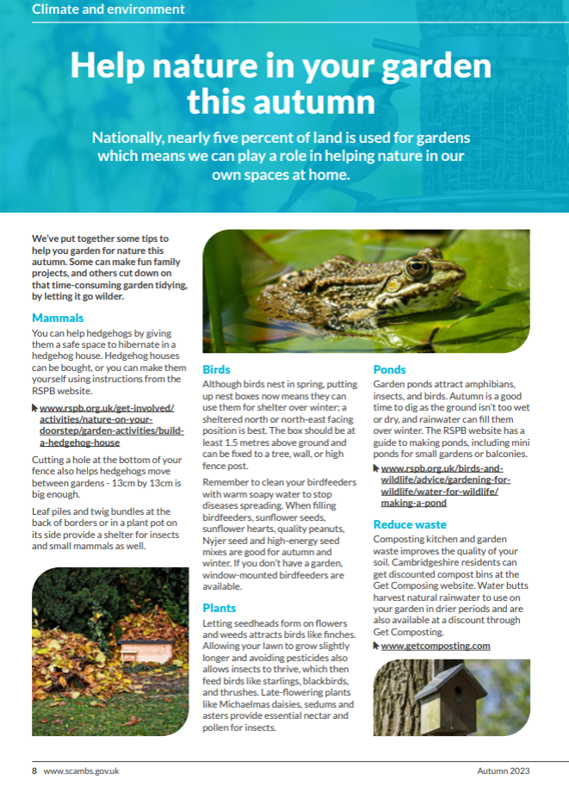
Figure 3: South Cambs Magazine Autumn 2023 p.8
Community Events
The SCDC Climate and Environment team frequently attend community events hosted by other organisations, such as Cambridgeshire ACRE, Romsey Mill Northstowe Youth Club, Cambridge Sustainable Food, village eco clubs, and local schools, to engage attendees about SCDC programmes and schemes, as well as consultation opportunities and council services.

PECT – Climate Education programme
The Peterborough Environmental City Trust (PECT) is a charity that, amongst other work, delivers a programme of eco education for young people. SCDC appointed PECT for a one-year engagement initiative from 2024-2025 involving 9 South Cambridgeshire schools. As part of PECT’s programme, students and teachers have committed to climate and nature-friendly initiatives, such as community litter picks, water harvesting, and eliminating single-use plastic. The program is currently being reviewed.

Partnerships
SCDC inputs into wider local and regional initiatives and we align our efforts with strategic targets for landscape-scale nature recovery.
Cambridgeshire Green Infrastructure Strategy (2011)
SCDC was a part of the Green Infrastructure forum which informed and shaped the Cambridgeshire Green Infrastructure Strategy (2011). This strategy covers several key projects and target areas within South Cambridgeshire, including Northstowe, Wicken Fen, Anglesey Abbey, Cambridge City, Cambourne, Wimpole, and West Cambridgeshire Woodlands. SCDC and GCSP have been involved in these district-wide projects through planning controls and supporting community initiatives.
Along with specific projects to improve green infrastructure, the strategy identifies main challenges as well as a range of opportunities for enhancement in South Cambridgeshire. It recommends providing more green infrastructure to meet the needs of the expanding population while improving links to the wider network. Just as important is the need to conserve and enhance the district’s rural and historic character, along with improving access to green infrastructure across the district.
Some opportunities identified:
- early enclosure sites within villages can provide open space and biodiversity opportunities – local green infrastructure
- traditional approaches along with new environmental stewardship schemes can create landscapes and habitats of high quality
- linking of fragmented woodland with other woodland, and hedged fields and parkland can strengthen biodiversity
- rivers and streams provide opportunities for conservation, enhancement and increased public access and enjoyment; wetlands and land around water courses/bodies can help manage flood risk
- heritage and gateway sites can help integrate visitors with the Green Infrastructure network
- rights of way or public routes can aid people and wildlife movement and connect sites and settlements around the network
The strategy, developed by multiple partners within Cambridgeshire, clearly lays out opportunities for improving green infrastructure within each district/area, but also maps out connections and corridors between each district and target area to help maximise biodiversity. It is used as a point of reference during planning application reviews to ensure proposed new green infrastructure is appropriate within the network.
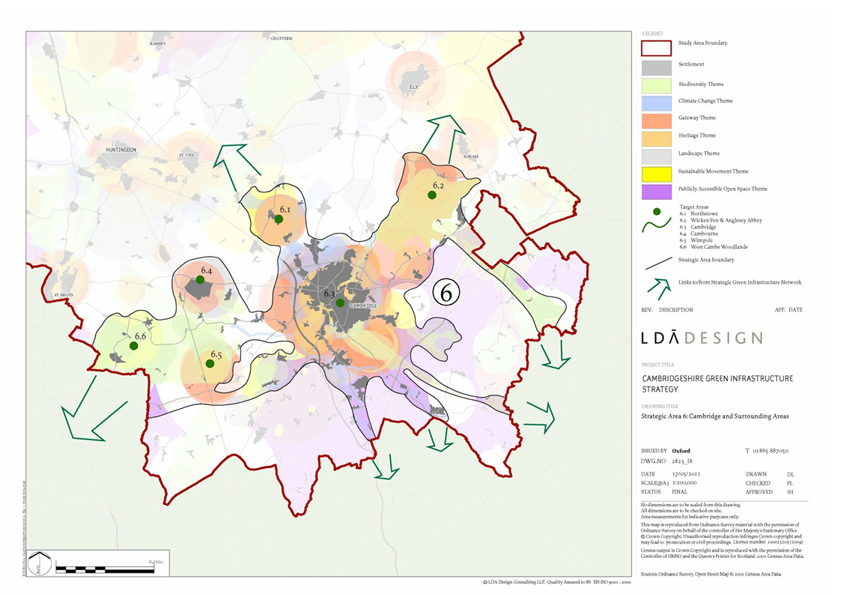
Figure 4: Cambridgeshire Green Infrastructure Strategy - Strategic Area 6: Cambridgeshire and Surrounding Areas p. 114

Cambridge Nature Network
SCDC is a key partner in the Cambridge Nature Network, which provides a systematic approach for nature recovery across Cambridge City and surrounding areas (approximately 10km radius extending into South Cambridgeshire). The network brings together local authorities, community organisations and landowners, and consists of existing and potential individual nature parks, nature reserves and farm habitats which are linked by nature-friendly farmland and wildlife-rich towns and villages. The priority map below shows core areas, stepping stones, and corridors that make up the network, many of which are within South Cambridgeshire. The report recognises the potential of creating and sustaining these nature connections through planning controls, specifically S106 and BNG requirements for new developments. The Nature Network intends to serve as a guiding basis for South Cambridgeshire and Cambridge City’s green infrastructure and nature recovery strategies.
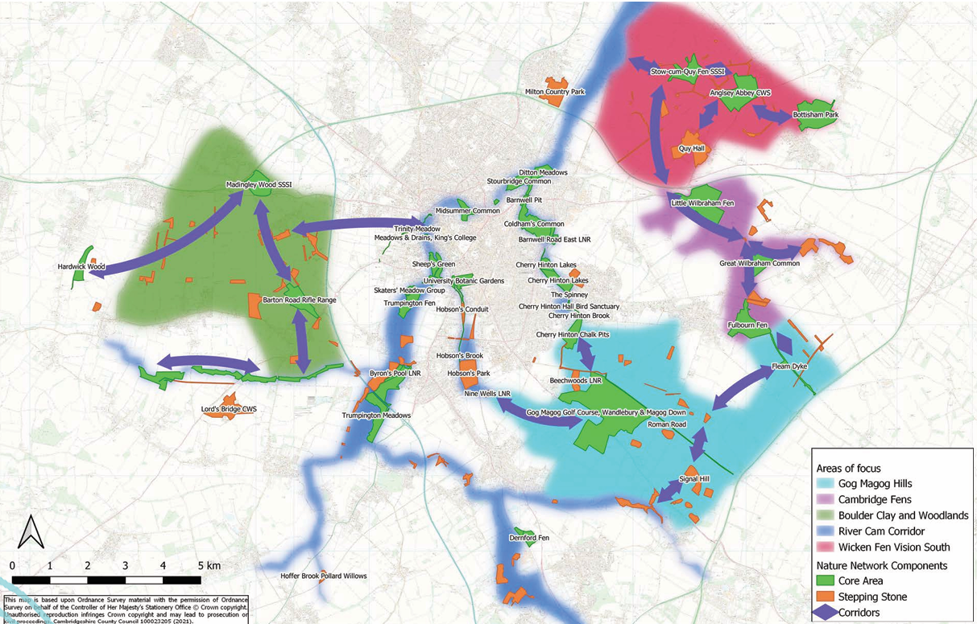
Figure 5 Cambridge Nature Network Priority Areas – Cambridge Nature Network Report Summary p.6-7
Natural Cambridgeshire
Natural Cambridgeshire is a partnership initiative within Cambridgeshire and Peterborough aimed at enhancing the natural environment across the area. Its core vision is to “Double Nature”, meaning doubling the area of rich wildlife habitats and natural green space within the combined authority area. Along with SCDC and other partners, Natural Cambridgeshire is supporting the county in the delivery of the new Cambridgeshire and Peterborough Local Nature Recovery Strategy (LNRS), to be published in 2026.
SCDC promotes Natural Cambridgeshire’s Local Nature Recovery Toolkit, which helps parish and town councils, community groups, and residents take action to support biodiversity and nature recovery in their areas, often through the creation of a local nature recovery plan or managing restoration projects.
Wildlife Trust BCN
The Wildlife Trust BCN plays a key role in establishing habitat banks used to offset the ecological impact of new developments, when impacts cannot be mitigated or BNG cannot be achieved onsite.
The Wildlife Trust BCN has also co-led in the creation of the Cambridge Nature Network which identifies priority landscape areas and vision for restoring wildlife areas around Cambridge (see above – Cambridge Nature Network). In addition, the Wildlife Trust provide ecological input into planning policy and development proposals to ensure biodiversity and wildlife are considered from the outset.
Cambridge Past, Present & Future (CPPF)
CPPF is a local charity dedicated to protecting and enhancing green spaces, heritage and the environment around Cambridge. Among other sites, they manage two public green spaces, Wandlebury Country Park, and Coton Countryside Reserve which are situated in South Cambridgeshire, making up significant nodes in the Cambridge Nature Network. They also work to preserve historic buildings in South Cambridgeshire including the Bourn Windmill and Hinxton Watermill.
Like the Wildlife Trust BCN, CPPF has worked with GCSP to identify and develop habitat bank sites, and inputs into development proposals with a view to conserve and enhance the natural environment, heritage, and Cambridgeshire’s rural character.
Cambourne – Miyawaki woodland
SCDC working with Cambourne Town Council has been successful in receiving a grant from the Coronation Living Heritage Fund to plant several micro woods. The Miyawaki woodland project aims to create densely wooded native forests that boost biodiversity, increase tree canopy cover and contribute to carbon sequestration. SCDC ecologists and officers continue to support tree-planting and community engagement for this project (more details in Section 2).

Summary – Our Biodiversity Duty Actions
In fulfilling our biodiversity duty, we have aligned with the priority of ‘Being green to our core’, by embodying good ecological practices within our own estates, and using our influence to motivate others to take action for biodiversity. Our grant schemes, the Community Chest Grant and Zero Carbon Communities Grant have funded more than 40 biodiversity projects between 2021 and 2025, while the outreach activities have engaged hundreds of participants including parish councillors, businesses, and residents. Our partnerships with different levels of government and environmental stakeholders contribute to a cohesive and strategic approach to tackling the ecological crisis in East Anglia, while protecting key species and heritage landscapes.

Section 2. Biodiversity Net Gain (BNG)

Policy Framework
Biodiversity Supplementary Planning Document (SPD) (2022)
The Biodiversity SPD (2022) provides guidance to developers on how to meet biodiversity-related policies in Cambridge City and South Cambridgeshire. It aims to integrate biodiversity into all stages of the planning and development process and aligns with various legislation such as the Environment Act 2021, Wildlife and Countryside Act 1981 and Conservation of Habitats and Species Regulations 2017. The SPD identifies biodiversity resources including statutory and non-statutory designated sites, protected and priority species and habitats as well as red listed species, to encourage safeguarding of these resources and ecological networks. It also provides guidance on best practice at each stage of the development process to protect and enhance biodiversity. Finally, it provides guidance on how BNG can be delivered, which includes on-site, off-site, or via statutory credits.
Greater Cambridge Local Plan (Draft) Policies for biodiversity
A new Greater Cambridge Local Plan, covering both Cambridge City and South Cambridgeshire and reflecting the shared service is being developed in consultation with residents. The new Local Plan is expected to be adopted in 2026. Several proposed policies relate to biodiversity and green spaces. These will be expanded upon in Section 5: Future Actions.

Biodiversity Duty
By law, LPAs must include the following BNG information to fulfil their biodiversity reporting duty
- The actions you’ve carried out to meet BNG obligations
- Details of BNG resulting, or expected to result, from biodiversity gain plans you’ve approved
- How you plan to meet BNG obligations in the next reporting period

Actions to meet BNG obligations
The Mandatory BNG Requirement
From 12 February 2024, the Local Planning Authority (LPA) for which South Cambridgeshire District Council is part along with Cambridge City Council, (Greater Cambridge Shared Planning) has been applying a mandatory Biodiversity Net Gain Pre-Commencement Condition to all relevant (except exempted) planning applications coming forward. This data has been captured and entered into the corporate BNG tracking software (Verna’s Mycelia), as well as being tracked through the corporate planning software (Uniform).
In Greater Cambridge, we have over the last two years also facilitated the creation of eight offsite advance habitat creation offset sites which cover a total land area of approximately 200 hectares. These sites are either already listed on DEFRA’s Biodiversity Register or are in the process of finalising the Section 106 Agreements and registering. These BNG Offset sites are where developers can purchase BNG credits in order to mitigate habitat loss from developments taking place in Greater Cambridge. For our work facilitating the creation of these sites, we won a category at Planning Awards in London in June 2025.
Through the negotiation and creation of Section 106 Agreements, we have put in place a chargeable monitoring regime for the offsite BNG Providers to cover the costs of LPA monitoring of BNG on their recovery sites by our ecology team.
Using the Mycelia software we have purchased from Verna, we are monitoring and will soon be able to more accurately report on the BNG created within our jurisdiction, both on and offsite.
In summary, Greater Cambridge Shared Planning has facilitated the creation of advance-creation habitat banks over the last two years and have published this information along with the associated Section 106 Agreements on this page. GCSP have also agreed twelve Section 106 Agreements for onsite delivery of BNG and also have at time of writing approximately 125 planning applications for which the mandatory BNG Condition has been applied for onsite BNG.
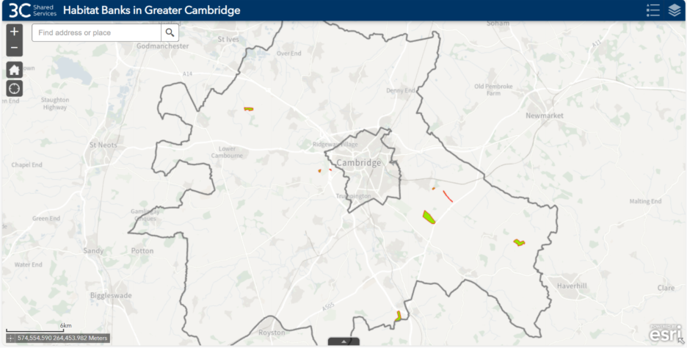
Figure 6. BNG offset provider sites in Greater Cambridge

Biodiversity Net Gain (BNG) Data
The BNG resulting or expected to result from these collected activities both on and offsite is difficult to quantify at present as we have just begun to receive offsite reports and the process for collating and tracking onsite BNG is still emerging, but we can report that as of September 2025 the offset providers in Greater Cambridge have provided 177 BNG Units to developers in order to offset damage to the natural environment as a result of development.
Greater Cambridge Shared Planning has through the set-up of these offset sites enabled the creation of new habitats and thus new opportunities for biodiversity to thrive here.

BNG Provider/Agent | Site | BNG unit sales as at 09/10/2025
Cambs County Council | Lower Valley Farm | 64.46
Wildlife Trust BCN | Flack Field, Fulbourn | 19.62
Groundworks | Devana Centre | 7.4
The BNG Partnership | Boxworth | 85.99
Cheffins | Coploe Hill, | 0 (S106 being finalised)
Cambridge Past Present & Future | Coton Reserve | 0 (S106 being finalised)
Total Units | - | 177.47

Table 1. BNG unit sales from offset sites created in Greater Cambridge

App No | Site Address | Decision | Ward | District | Type | Deed Date
21/00660/FUL | Land Adjacent 12-131 Ditton Fields, Cambridge, Cambridgeshire | Granted | Abbey | Cambridge City Council | BNG - Provision | 05/11/2021
22/01384/FUL | Beech Farm, Church Street, Harston, Cambridgeshire CB22 7NR | Granted | Harston & Comberton | South Cambridgeshire District Council | BNG - Provision | 23/02/2023
22/02088/FUL | Bourn Golf Club, Health and Fitness Club, Toft Road Bourn Cambridgeshire CB23 2TT | Granted | Caldecote | South Cambridgeshire District Council | BNG - Provision | 03/11/2022
22/05549/OUT | TWI Granta Park, Great Abington, Cambridgeshire CB21 6AL | Granted | Linton | South Cambridgeshire District Council | BNG - Provision | 18/01/2024
23/01335/OUT | Land East of Ermine Street, Caxton, Cambridgeshire | Granted | Caxton & Papworth | South Cambridgeshire District Council | BNG - Provision | 26/07/2024
23/04233/FUL | Fitzwilliam College, Storeys Way, Cambridge, Cambridgeshire CB3 0DG | Granted | Castle | Cambridge City Council | BNG - Provision | 09/08/2024
23/04590/OUT | Land South Of Coldhams Lane, Cambridge, Cambridgeshire | Granted | Cherry Hinton | Cambridge City Council | BNG - Provision | 31/01/2025
23/04687/FUL | Barnwell Local Centre, Barnwell Road, Cambridge, Cambridgeshire CB5 8RG | Granted | Abbey | Cambridge City Council | BNG - Provision | 26/11/2024
23/04952/FUL | 19-35 Regent Street, Cambridge, Cambridgeshire CB2 3AS | Granted | Market | Cambridge City Council | BNG - Provision | 18/12/2024
24/01080/OUT | Land At Green End/Heath Road, Gamlingay, Sandy SG19 3JZ | Granted | Gamlingay | South Cambridgeshire District Council | BNG - Provision | 10/04/2025
24/01354/FUL | 137 And 143 Histon Road, Cambridge, Cambridgeshire CB4 3HZ | Granted | Arbury | Cambridge City Council | BNG - Provision | 06/03/2025
24/03285/OUT | Land Southwest Of Lanacre 86 Chrishall Road, Fowlmere, Cambridgeshire SG8 7RY | Granted | Foxton | South Cambridgeshire District Council | BNG - Provision | 31/07/2025

Table 2. Section 106 Agreements which include BNG Provision in Greater Cambridge

Future Planning Actions for Biodiversity
In the next reporting period, we aim to continue to support applicants through the planning system through the provision of expert advice from our team of three full-time in-house ecologists and the systems and process that we have put in place to record and report on BNG.
In order to track, monitor and report on our BNG data, we purchased a specialist software package (Verna’s Mycelia), which we will be using to collate data from other corporate systems (Uniform, Exacom) to obtain a fuller picture of what is going on. The Mycelia tool, imports and then checks the completeness and quality of submitted DEFRA Biodiversity Metrics: a tool provided by the Department for Environment, Food & Rural Affairs to quantify biodiversity losses and gains in BNG and is the standard and only accepted mechanism for reporting BNG.
In addition to the BNG being delivered through the Planning system, GCSP have also overseen the funding and delivery of a £40K woodland creation project. This project, delivered in collaboration with the Cambourne Town Council will see the creation of four Miyawaki woodlands and associated wildflower meadows on the outskirts of Upper Cambourne and which will deliver a significant net uplift in Biodiversity against the present baseline at the site. This woodland is not being used as an offset provider site but is outside of that process and sits as an example of a community-focused project to increase and enhance biodiversity proximate to an urban population.
Following the Miyawaki method of micro-forest generation, this project will create a different type of woodland and associated wildflower meadow and become a small biodiversity hotspot.
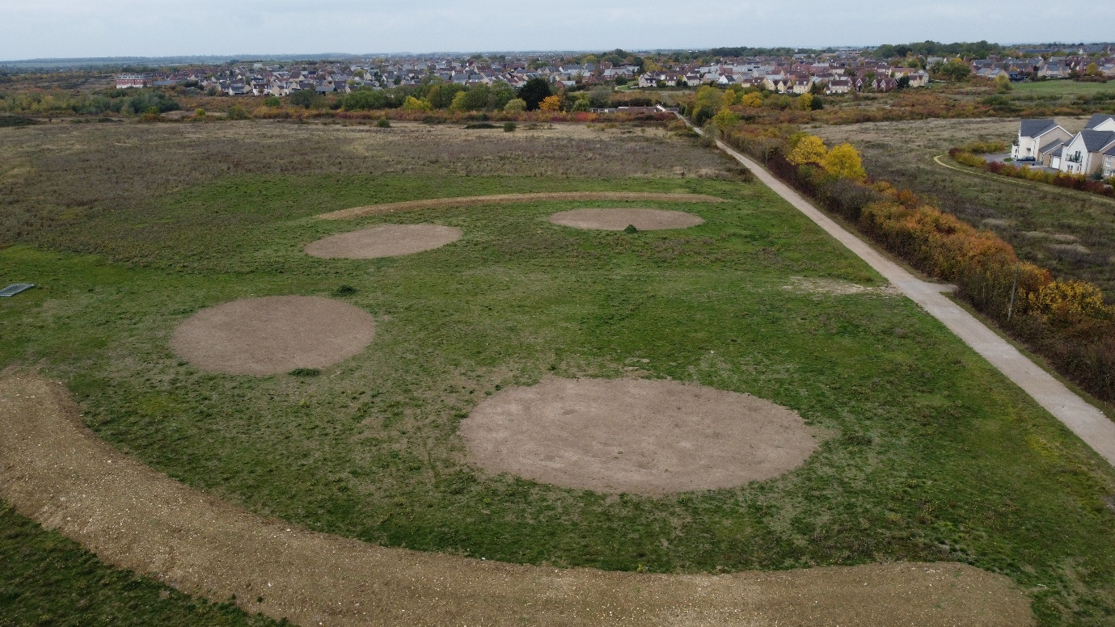
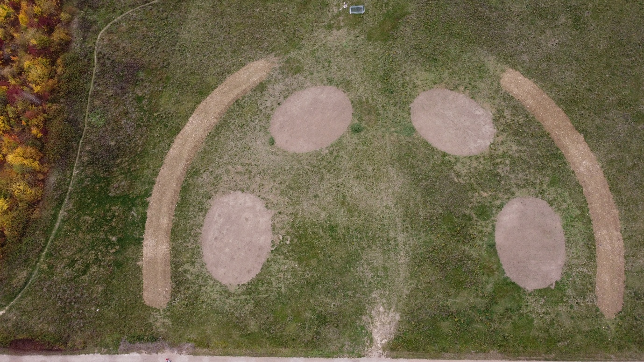
Figure 7. BNG being delivered as part of local micro-forest planting initiative in Upper Cambourne

Section 3. Monitoring and Evaluation
The Zero Carbon and Doubling Nature Action Plan 2021-2025 (ZCDNAP) has been monitored annually from 2021 – 2024. Progress tracked across four years has been compiled in Appendix A.
Each of our biodiversity actions have been evaluated to capture both quantitative and qualitative results and to inform future actions. The evaluation can be found in Appendix B.
ZCDNAP actions have been completed or incorporated into the Climate and Nature Strategy and Action Plan (2026). The next section will detail continuing actions and future actions for biodiversity.

Summary – Monitoring and Evaluation
Between 2021 and 2025, SCDC made significant strides in enhancing biodiversity across its estate, planning processes, partnerships, and community engagement. Over 320 trees and hedge whips were planted on Council estates, including 262 on HRA land with a dedicated maintenance plan, while continuing tree audits will ensure proper care and enhancement of the areas managed for nature. Biodiversity efforts also extended to watercourses in the district through partnerships with local groups and training for staff. Planning achievements included embedding biodiversity policies into the Greater Cambridge Local Plan (draft) and adopting a new Biodiversity SPD with a 20% Biodiversity Net Gain (BNG) ambition, supported by an expanded ecology team and BNG offset sites across the district.
Community initiatives flourished through grants funding 43 biodiversity projects, distribution of 758 native trees, and community outreach via publications, webinars, and climate conferences. Despite these successes, challenges remain, including unmet demand for funding, difficulty achieving BNG on smaller developments, and limited staff capacity for continued involvement in projects. Importantly, climate change and extreme weather patterns continue to hinder some efforts for nature recovery such as maintaining habitats in watercourses and keeping plants well-watered in dry conditions. Looking ahead, the Council plans to refine planning policies, support parish-led nature recovery plans, and continue engaging residents and other stakeholders through guides, events, and collaborative networks. Evaluation of these past actions will also inform future strategies as we look to eliminate emissions and double nature by 2050.

Section 4. Relevant Strategies
SCDC strategies fit into a wider picture for biodiversity locally, nationally, and globally; it is important to align our approaches with relevant strategies to ensure we are an effective partner in delivering landscape-scale impacts; the following strategies can guide us in reviewing our past approaches and inspire future actions. Detailed considerations can be found in Appendix E.

UN Environment Programme Convention on Biological Diversity of 1992
Key Objectives:
- Conservation of biological diversity
- Sustainable use of natural resources
- Sharing benefits of nature (I.e. Genetic resources)
- Recognising the role of indigenous and local communities in biodiversity conservation
SCDC’s strategies reflects the UN Convention on Biological Diversity by requiring biodiversity net gain in new developments, protecting habitats, and promoting sustainable resource use. Through the Doubling Nature and Zero Carbon strategies, it has encouraged circular economy practices, efficient water and land use, and highlighted co-benefits like improved health and climate resilience. The Council also empowers local communities and parishes with funding, training, and citizen science initiatives to support grassroots biodiversity efforts. South Cambridgeshire and East Anglia on the whole has a wealth of biological diversity connected to its heritage. More effort could be made to protect local native species of plants and animals, for example planting more native heritage trees, and enhancing chalk lands and streams.

Cambridgeshire and Peterborough Local Nature Recovery Strategy (LNRS) (DRAFT)
The Cambridgeshire and Peterborough LNRS was developed by Cambridgeshire County Council in partnership with Cambridgeshire & Peterborough Combined Authority (CPCA), Natural Cambridgeshire, local councils and community groups. This document will guide authorities’ efforts to enhance and restore and enhance nature across one of England’s most nature-depleted areas.
Natural Cambridgeshire has identified six priority landscapes within Peterborough and Cambridgeshire to aid in landscape-scale nature recovery; of these, three sit within South Cambridgeshire:
- Cambridgeshire Nature Network – the area of downland, fen and wooded farmland around Cambridge and the river Cam and its chalk stream tributaries extending into Essex.
- Connected Fens – the area of internationally important remnants of ancient fen and washland habitats that now cover less than 1% of the Fens. They include the richest areas of habitat locally, supporting many rare and iconic species. Major restoration is planned and taking place in the Great Fen, Wicken Fen and Ouse Washes areas
- West Cambridgeshire Hundreds – the ancient woodlands and parklands west of Cambridge to the Bedfordshire border with populations of iconic plants and invertebrates with restricted distributions in England
Broad and local habitats have also been identified in the LNRS to help focus our nature-restoration efforts with tailored interventions for each habitat.
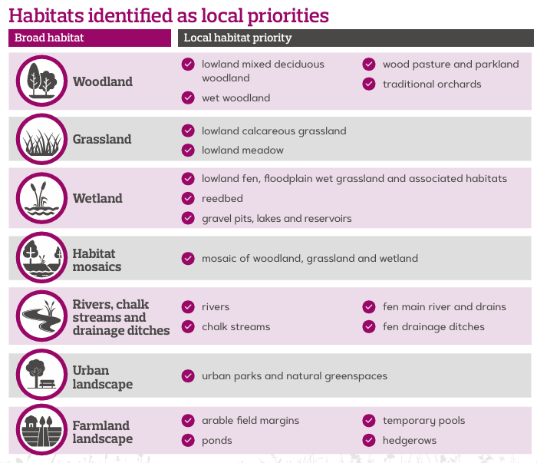
LNRS Key Objectives:
- Air Quality - Improve the air quality of Cambridgeshire and Peterborough and reduce impacts on habitat and species.
- Climate Change - Strengthen the resilience of Cambridgeshire and Peterborough’s environment against the effects of extreme weather and climate change impacts.
- Communities - Enhance a sense of place where both people and nature can benefit
- Doubling Nature - Support Natural Cambridgeshire’s doubling nature ambition to at least double the area of rich wildlife habitats from approximately 8% to more than 16% by 2040 and increasing beyond that
- Development - Encourage existing, new and large developments to incorporate wildlife friendly features in gardens, buildings and land
- Environmentally friendly farming - That farming and food production across Cambridgeshire and Peterborough is conducted using environmentally sustainable practices, recognising the importance of food production and the potential of farming to support nature recovery.
- Historic environment - Celebrate Cambridgeshire and Peterborough’s rich culture, built / natural heritage, and its geology and surrounding environment.
- Lawton Principles - Respond to the existing deficit of rich wildlife areas across Cambridgeshire and Peterborough by using the Lawton Principles of ‘better, bigger, more and joined up’.
- Peatland - Promote healthy functioning peatlands to store and capture carbon whilst not increasing methane emissions.
- Water quality and resources - Promote integrated water management techniques considering water resources, quality, and resilience to flooding.

Generally, SCDC actions align well with LNRS strategic aims, however our interventions do not specifically target priority landscapes to capitalise on their unique characteristics and opportunities whereas the LNRS tailors specific solutions to enhance each priority landscape and habitat. As we own and control only a very small proportion of land in the district, partnership and collaboration with special interest groups and other local authorities will be key to implement LNRS recommendations. In particular, farmland, wetland and chalk streams present significant opportunities for nature recovery in South Cambridgeshire.
The LNRS actions can also guide us in linking different ecological functions, such as waterway improvements from better farming practices, or using corridors and features in urban landscapes to connect surrounding rural landscapes. In aligning the key objectives, Appendix E compares SCDC actions with LNRS guidance, and reveals gaps where more action is needed, for example in encouraging environmentally friendly farming.

South Cambridgeshire Local Plan (2018)
Key Objectives:
- Integrating biodiversity into the built environment
- Prioritise protected species and habitats
- Protect and enhance existing features on brownfield sites
- All developments to deliver 20% biodiversity net gain
- All new developments contribute towards the enhancement of the green infrastructure network within the district
The South Cambridgeshire Local Plan (2018) set goals to integrate biodiversity into development, protect habitats and species, and enhance brownfield sites, and contributions to green infrastructure. SCDC’s Biodiversity SPD supports these aims by promoting habitat creation, requiring early ecological assessments, and mandating long-term management plans. It encourages green infrastructure like SuDS and green roofs and contributes to the Local Nature Recovery Strategy to map priority habitats. Brownfield sites undergo biodiversity surveys when ecologically significant, ensuring alignment with the Local Plan’s objectives.

Cambridgeshire County Climate Change and Environment Strategy 2022
Key Objectives:
- Creating a wildlife-rich, resilient, productive and sustainable landscape
- Harnessing the power of local communities – place-based approach
- Increase knowledge of nature-based solutions for carbon reduction and climate change
- Embed environmental value in decision making Improve biodiversity across Council estates
Cambridgeshire County’s strategy aims to create a wildlife-rich, resilient landscape through community-led action, nature-based solutions, and environmentally informed decision-making. SCDC aligns with this through its Doubling Nature Strategy, promoting nature-friendly farming, managing 21 areas for nature on Council estates, and exploring land expansion for biodiversity. It empowers communities via inclusive grants and outreach and embeds environmental values in all decisions such as procurement and recruitment and raises awareness through sustainable gardening and tree planting campaigns.

Cambridge City Biodiversity Strategy (2022-2030)
Key Objectives:
- Focus conservation efforts on priority habitats and species
- Integrate Cambridge’s green spaces into a wider ecological network
- Promote easy access to high-quality green spaces
Cambridge City’s Biodiversity Strategy (2022–2030) prioritises conservation of key habitats and species, ecological connectivity, and public access to quality green spaces. SCDC shares these goals under the draft Local Nature Recovery Strategy, which guides targeted habitat restoration. As a partner in the Cambridge Nature Network and Green Infrastructure Network, SCDC helps connect priority sites across the region. Its Doubling Nature Strategy aims to expand wildlife-rich areas and tree canopy cover, while planning policies ensure new developments include accessible green infrastructure that enhances both biodiversity and public enjoyment.

Cambridgeshire & Peterborough County Wildlife Sites (CWS) Handbook
- Engage the community about biodiversity through education and outreach – Biodiversity mainstreaming,
- Embed biodiversity in planning and development (BNG, green infrastructure)
- Improve biodiversity on Council-owned land Collaborate with residents, businesses, institutions, and conservation organisations
- Local plans should include policies that protect and enhance CWSs
- Local authorities can provide advice and support to landowners, facilitate funding or grants for habitat management, promote sympathetic land use practices
The Cambridgeshire & Peterborough CWS Handbook promotes biodiversity through education, planning, land management, and collaboration. SCDC supports these aims with community outreach via newsletters, events, and webinars, and embeds biodiversity in planning through its Biodiversity SPD. It enhances Council-owned land with tree planting and wildflower areas, partners with conservation groups, and offers grants and advice to landowners. While SCDC recognises County Wildlife Sites in its Doubling Nature Strategy, it has yet to adopt specific policies for their protection and enhancement.

Summary – Review of Relevant Strategies
SCDC’s biodiversity strategies and actions were highly aligned with other existing strategies in the following areas:
- Directly enhancing biodiversity on Council-managed estates
- Supporting Parishes and local communities to initiate their own biodiversity projects through outreach / education, grant-funding and guidance
- Using planning controls such as BNG and green infrastructure requirements to ensure biodiversity is conserved and enhanced in new developments
- Mitigate and prevent the loss of biodiversity through climate-friendly actions
- Partner with local nature conservation organisations to carry out biodiversity projects
- Aim to "Double Nature"
This review exercise also revealed some gaps in our strategies, which highlight some unique challenges in protecting and enhancing nature but also help us focus our efforts on new opportunities:
- Exercise more influence in the agriculture sector to promote nature-friendly farming practices
- Consider more equal access to nature and green spaces in the planning process, through S106 conditions, site design, or in selecting BNG offset sites; encourage wildlife-friendly features within developments
- Engage more with businesses / private sector to help them achieve climate and nature-friendly targets
- Facilitate more initiatives for rewilding public spaces, especially along transit corridors
- Collaborate more with other local authorities to create a joined-up, well-connected network of habitats, including creation of strategic sites and wildlife corridors
- Encourage and facilitate nature-recovery for specific habitats and species, such as chalk and wood land.

Section 5. Future Actions
Reflecting on our biodiversity strategies and actions over the past five years and evaluating them alongside relevant frameworks offers valuable insight into where our efforts are succeeding and where they must evolve. These priorities are reflected in emerging plans and strategies introduced below, which will guide us for the next five years.

SCDC Corporate Plan 2025 – 2030
The new corporate plan seeks to address the ecological crisis by protecting and enhancing nature and biodiversity across the district. ‘Being green to our core’ remains one of the five priorities for the next five years, during which we will endeavour to cut our operational carbon emissions by 75% by 2030 and support parish councils, local communities and businesses to respond to the climate and ecological emergencies. Specifically, our actions on biodiversity will be guided by the Climate and Nature Strategy, the Greater Cambridge Local Plan, and Cambridgeshire and Peterborough Local Nature Recovery Strategy.

Climate and Nature Strategy + Action Plan
The Climate and Nature Strategy has been developed in consultation with SCDC colleagues, GCSPS ecologists, local businesses, organisations, community groups, and residents, to reflect priorities for climate change mitigation and adaptation as well as biodiversity and nature over the next five years (2026-2030). Many of the previous actions adopted within the previous Zero Carbon and Doubling Nature strategies will continue, while new actions seek to fulfil new ambitions and address gaps identified in the previous strategies. The new strategy includes eight focus areas: Adaptation and Resilience, Transport, Energy & Retrofit, Nature and Water, Sustainable Food, Waste Minimisation, Community Support & Behaviour Change, Business, Supply Chain, and Finance. It identifies unique challenges that could potentially threaten biodiversity, but also opportunities and past successes we can build on to enhance nature and resilience.
There are several key targets within the Nature and Water focus area:
- Double the quantity and quality of land managed for nature, including increasing the area of land managed for nature from 7% to 14% by 2050 in the district.
- Seek to introduce a 20% Biodiversity Net Gain requirement for major new developments through the Greater Cambridge Local Plan, above the national standard requirement of 10%
We will also seek to:
- Prioritise nature-based solutions when considering actions to adapt to the impacts of climate change.
- Ensure any land enhanced for nature is resilient to the impacts of climate change and increases sustainable long-term habitats for biodiversity. The following actions are proposed to help achieve these targets:
On our own estate:
- Pilot using alternative methods to control weed growth and avoid harmful environmental impacts in new contracts

- Continue to identify and deliver opportunities for tree planting and biodiversity enhancements such as supporting rewilding, wildflower areas and enhanced management of verges for nature on land we own including as part of our housing estate and Milton County Park where funding is available

- Support the enhancement and protection of nature and our watercourses through working with partners on our Awarded Watercourses

- Use opportunities from the development of the Waterbeach Renewable Energy Network project to create high quality areas for nature

In the wider district:
Place shaping
- Progress planning policies which protect and enhance nature as part of wider work on green infrastructure in the emerging ‘Greater Cambridge Local Plan’.

- Work with the Community Health Initiative on the development of a contemporary open spaces policy for the ‘Great Cambridge Local Plan’ that places wellbeing as a central policy objective.

- Seek to introduce a 20% Biodiversity Net Gain requirement for major new developments through the Greater Cambridge Local Plan, above the national standard requirement of 10%.

- Require new housing to meet the water efficiency standards in the current ‘South Cambridgeshire Local Plan’ (maximum of 110 litres/person/day) and explore where higher standards could be adopted in the new ‘Greater Cambridge Local Plan’.
Showcasing
- Continue to deliver the project to plant and maintain Miyawaki woodlands in Cambourne
Partnerships
- Work with the Cambridge Water Scarcity Group and other stakeholders to advocate for solutions to address short term water supply issues and longer-term strategies to identify solutions which protect the environment and enable growth needs to be met.

- Contribute, in collaboration with partners, to the delivery of the ‘Local Nature Recovery Strategy’ for Cambridgeshire and Peterborough which sets out plans for nature and habitat recovery, including within South Cambridgeshire.

- Work with partners to support the delivery of the Greater Cambridge Chalk Streams project, identifying opportunities to work with landowners on the protection and enhancement of chalk streams.

- Secure funding from developers for partners to protect and enhance nature.

- Work with local farmers to promote best practice for sustainable agriculture, regenerative farming and solutions for nature on land managed for agriculture.
Involving, engaging and communicating
- Engage parishes on the rewilding of parish-owned land including reduced mowing and wildflower planting and the implementation of a Parish Pollinator Pledge.

- Produce and promote guides for residents on managing their gardens for nature.
- Deliver a programme of engagement on nature and biodiversity (to include webinars, newsletter articles, and social media) with stakeholders, including communities and parish councils.

- Provide grants to villages to plant trees and help biodiversity and nature recovery projects (e.g., rewilding), such as with the previous ‘Community Chest’ and the ‘Six Free Trees’ grants.

- Work with partners to support communities to reduce their water consumption through promoting water-saving messaging.
Other actions not listed above, within other themes also contribute to overall environmental health which impacts biodiversity, for instance sustainable food production under Sustainable Food. The full list of actions from the Climate and Nature Strategy can be found here.

Greater Cambridge Local Plan (Draft)
The Greater Cambridge Local Plan proposes the following policies for the protection and enhancement of biodiversity:
- Policy BG/BG: Biodiversity and geodiversity
This policy will require major development to achieve a minimum 20% biodiversity net gain when this is feasible and effective, calculated using DEFRA Statutory BNG metric. BNG should be delivered on-site where possible; off-site will be encouraged to deliver replacement habitat within areas identified within the Cambridgeshire and Peterborough Local Nature Recovery Strategy priority areas. Developments that adversely affect biodiversity or geological importance will not be permitted, unless public benefits significantly outweigh any adverse impacts. This policy will also seek wider environmental net gains in addition to BNG.
- Policy BG/GI: Green and Blue infrastructure
This policy will require all development proposals to include green and blue infrastructure that is appropriate to its local context. Green and blue infrastructure will support BNG by providing links between habitats and with the wider ecological network; it will also promote healthy living by providing accessible and socially inclusive spaces. Green infrastructure will also enhance the water environment, and support climate mitigation and adaptation. A list of strategic green infrastructure initiatives which have the potential to enhance the existing network is included in this policy.
- Policy BG/TC: Improving Tree Canopy Cover and the Tree Population
This policy will require development proposals to preserve, protect and increase the amount and distribution of tree canopy cover, protect and enhance the tree population onsite (including diversity and distribution), protect existing trees and hedgerows of value, and provide sufficient space above and below ground for trees and other vegetation to mature. It will also ensure trees and hedgerows are replaced where felling is necessary. This policy will also encourage the provision of greater treescape design diversity and of locally appropriate and long-lived tree species in appropriate locations.
- Policy BG/RC: River corridors
This policy will require development located along the River Cam and its tributaries to protect, enhance and restore natural features (i.e. renaturalisation). It will support the aims of the Cambridge Chalk Streams project, restore natural floodplains and integrate green infrastructure to protect communities at risk of flooding. It’ll establish riparian habitats where appropriate and protect and enhance the existing landscape and character of river corridors. It will support enhanced access to the river corridors for walking and cycling while protecting and enhancing habitats for biodiversity, through delivery of projects such as the Cam Valley Trail.
- Policy BG/PO: Protecting open spaces
This policy will identify and protect open spaces such as village greens, parks, sports and recreation areas, allotments, community orchards, Protected Village Amenity Areas, and Local Green Space.
- Policy BG/EO: Providing and enhancing open spaces
This policy will provide guidance on open space and recreation provision to address increased needs for open spaces from new developments, this includes sports pitches, play space for youth, and more informal spaces. Community food growing opportunities will also be sought. Provisions will be onsite where appropriate, otherwise financial contributions will be sought to help improve off site facilities. Open space standards that detail the required quantity and accessibility of open space will be used and will differ depending on local context and character.

Other Future Actions
Nature and biodiversity are interwoven into multiple work areas at SCDC; while some actions can be succinctly captured within emerging biodiversity strategies, others are captured by wider programmes. In the next five years, SCDC will continue to offer the following initiatives which will have significant biodiversity benefits as well as other co-benefits:
- SCDC Community Chest Grant – Biodiversity - £10,000 per year to support biodiversity projects
- Six Free Trees programme – six free native tree whips or one large tree for every parish in South Cambridgeshire
- Continue our partnership within the Cambridge Chalk Stream Project
- Support Cambridgeshire County Council’s Local Nature Recovery project (helping parishes/clusters develop local nature recovery plans)
- Continue conducting tree surveys on our housing estates
- Continue sharing good practice and case studies to inspire action for nature

Future Actions Summary
Over the next five years, SCDC is sharpening its focus on biodiversity and climate resilience through new and evolving strategies. Building on lessons from the past, the council is aligning its future actions with national frameworks and local ambitions to address the ecological crisis.
Guided by the SCDC Corporate Plan 2025 – 2030 which reaffirms the district’s commitment to ‘being green to our core’, we will continue cutting operational carbon emissions as we move towards our target of a 75% reduction by 2030 and maximise and expand areas managed for nature on our own estates. Our ambition goes beyond internal goals - SCDC aims to empower parish councils, communities, and businesses to take meaningful action in response to climate and ecological emergencies through continuing engagement and funding support. Biodiversity efforts will be guided by three key documents: the Climate and Nature Strategy (2026), the Greater Cambridge Local Plan (2026), and the Cambridgeshire and Peterborough Local Nature Recovery Strategy (2026). Carrying on from the previous Doubling Nature Strategy (2021), the Climate and Nature Strategy (2026) aims to double the land managed for nature from 7% to 14% by 2050, ensuring climate-resilient habitats. Biodiversity will also be measurably increased through BNG Planning requirements which will seek to introduce a 20% BNG requirement above pre-development baselines. Additionally, we will continue to support biodiversity projects on parish and public lands and encourage private land and house owners to implement nature-friendly measures.
Biodiversity efforts will be supported by the Greater Cambridge Local Plan which will not only guarantee biodiversity net gain but also ensure the integration of green infrastructure to connect habitats and support community wellbeing. Specific policies will support the protection and enhancement of tree canopy cover, river corridors and heritage landscapes under the backdrop of increased development pressures.
Together, these initiatives form a cohesive vision for a greener, more resilient South Cambridgeshire, one where nature and biodiversity are not just protected but actively restored. As these emerging plans continue to evolve throughout, diverse perspectives will contribute to a collective vision for the path forward.

